Software design pattern

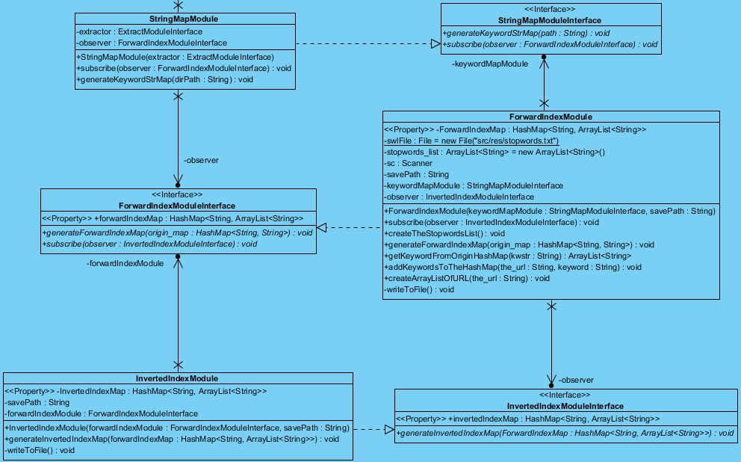Observer pattern

There are three classes for generating a hash map of keywords

Observer pattern is used in those 3 classes. Since that those 3 class are highly relied, observer pattern can update the final hash map automatically and ensure the consistency of the hash map.

Strategy pattern

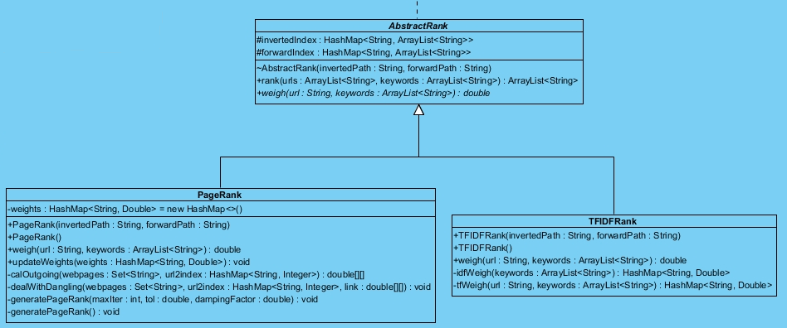

In our search engine, we use an abstract class to declare the method for website ranking. We have two ranking algorithm which is “PageRank” and “TFIDFRank” for sorting the webpage.

For the keywords array, we use “TFIDFRank” to weight the webpage. For the hyperlink array, we use “PageRank” to weight the webpage.